Monitor GBase 8s Using System Tables
南 大 通 用 数 据 技 术 股 份 有 限 公 司
General Data Technologies Co., Ltd.
 | 版权所有© GBASE 2021
 | 天津总公司：中国天津华苑产业区海泰发展六道6号海泰绿色产业基地J座5层  电 话：022-58815678  传 真：022-58815679  北京分公司：北京市朝阳区太阳宫中路12号太阳宫大厦10层1008室  电 话：010-88866866  传 真：010-88864556  http://www.gbase.cn  E-mail:info@gbase.cn

Monitor GBase 8s Using System Tables，南大通用数据技术股份有限公司
版权所有© GBASE 2021，保留所有权利。

作者：刘凡梁
终审者：

版权声明
本文档所涉及的软件著作权、版权和知识产权已依法进行了相关注册、登记，由南大通用数据技术股份有限公司合法拥有，受《中华人民共和国著作权法》、《计算机软件保护条例》、《知识产权保护条例》和相关国际版权条约、法律、法规以及其它知识产权法律和条约的保护。未经授权许可，不得非法使用。
免责声明
本文档包含的南大通用公司的版权信息由南大通用公司合法拥有，受法律的保护，南大通用公司对本文档可能涉及到的非南大通用公司的信息不承担任何责任。在法律允许的范围内，您可以查阅，并仅能够在《中华人民共和国著作权法》规定的合法范围内复制和打印本文档。任何单位和个人未经南大通用公司书面授权许可，不得使用、修改、再发布本文档的任何部分和内容，否则将视为侵权，南大通用公司具有依法追究其责任的权利。
本文档中包含的信息如有更新，恕不另行通知。您对本文档的任何问题，可直接向南大通用数据技术股份有限公司告知或查询。
未经本公司明确授予的任何权利均予保留。
通讯方式
南大通用数据技术股份有限公司
中国天津华苑产业区海泰发展六道6号海泰绿色产业基地J座5层 (300384)
电话：400-013-9696 邮箱：info@gbase.cn
商标声明
是南大通用数据技术股份有限公司向中华人民共和国国家商标局申请注册的注册商标，注册商标专用权由南大通用公司合法拥有，受法律保护。未经南大通用公司书面许可，任何单位及个人不得以任何方式或理由对该商标的任何部分进行使用、复制、修改、传播、抄录或与其它产品捆绑使用销售。凡侵犯南大通用公司商标权的，南大通用公司将依法追究其法律责任。

目录
1. Instance 1
1.1. Instance Overall 1
1.1.1. Instance Environment value 1
1.1.2. Instance Running Info 1
1.1.3. OS Machine Info 2
1.1.4. Onconfig Parameters 3
1.1.5. Instance Profile 3
1.1.6. Checkpoint 5
1.2. CPU 5
1.2.1. CPU VP Profile 5
1.2.2. CPU VP List 6
1.3. Memory 7
1.3.1. Buffer Pool 7
1.3.2. LRU 7
1.4. Disk 8
1.4.1. DBSpaces 8
1.4.2. Chunks 9
1.4.3. Chunks I/O 9
1.4.4. Logical Log 10
1.4.5. Logical logfile backup times (onbar) 11
1.4.6. Physical Log 11
1.5. Network 12
1.5.1. Network SQLHosts 12
1.5.2. Network Status 12
1.6. Session 13
1.6.1. Sessions Connection Time 13
1.6.2. Sessions Idle Time 13
1.6.3. Sessions Waiting on Resources 14
1.6.4. Sessions I/O 15
1.6.5. Sessions Lock 15
1.7. SQL 16
1.7.1. Current Executing SQL 16
1.7.2. Current Slowest SQL 17
1.7.3. History Slowest SQL 17
1.8. Lock 19
1.8.1. Locks on Table 19
1.8.2. Lock List and Lock waiter 19
1.9. Transaction 20
1.9.1. Transactions Info 20
1.9.2. Transactions and Logs 21
2. Database 22
2.1.1. Database Basic Info 22
2.1.2. Database Space Usage 22
3. Database Objects 24
3.1. Table 24
3.1.1. Table Created time 24
3.1.2. Tables Space 25
3.1.3. Tables IO 26
3.1.4. Tables In Rootdbs 27
3.1.5. Tables Update Statistics 28
3.1.6. Temp Table 28
3.2. Index 29
3.2.1. Index Created Time 29
3.2.2. Index Script 30
3.2.3. Index Space 31
3.3. Procedure 33
3.3.1. Procedure Script 33

- Instance
  - Instance Overall
    - Instance Environment value
数据库实例的环境变量定义情况
dbaccess sysmaster
select env_id,env_name,env_valuefrom sysenv;
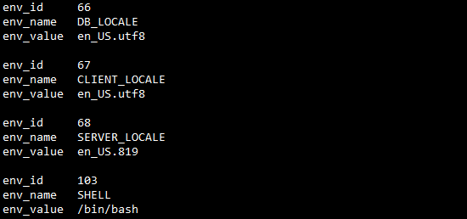
说明 | 数据库实例的环境变量值有：DB_LOCALE,GL_DATE等。不但可以查询数据库实例当前定义的环境变量的值，也可以在当操作系统gbasedbt用户的相关环境变量文件被删除的情况，可以通过此结果来恢复。
    - Instance Running Info
数据库实例的运行信息
dbaccess sysmaster
select
dbinfo('UTC_TO_DATETIME',sh_boottime) start_time,
current year to second - dbinfo('UTC_TO_DATETIME',sh_boottime) run_time,
sh_maxchunks as maxchunks,
sh_maxdbspaces maxdbspaces,
sh_maxuserthreads maxuserthreads,
sh_maxtrans maxtrans,
sh_maxlocks locks,
sh_nlrus buff_lrus,
sh_longtx longtxs,
dbinfo('UTC_TO_DATETIME',sh_pfclrtime) onstat_z_running_time
from sysshmvals;
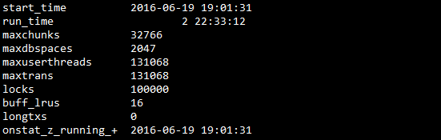
说明 | 启动时间、最大的chunk和dbspaces配置、最大用户线程、事务数，配置的lock数量、逻辑日志的个数
    - OS Machine Info
数据库实例的操作系统信息
dbaccess sysmaster
select * from sysmachineinfo;
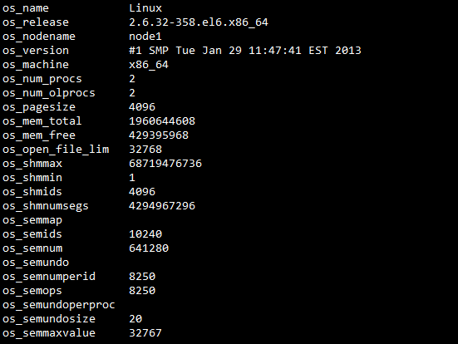
说明 | 快速了解OS相关信息
    - Onconfig Parameters
数据库实例的配置文件信息
dbaccess sysmaster
select cf_name,cf_effective,cf_original,cf_default from sysconfig;
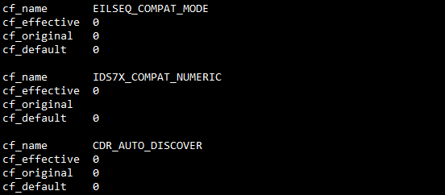
说明 | 查看数据库实例参数的配置：cf_name 参数名 cf_effective 当前值 cf_original 修改前值 cf_default 默认值
    - Instance Profile
实例运行的概要信息
dbaccess sysmaster
select * from sysprofile;
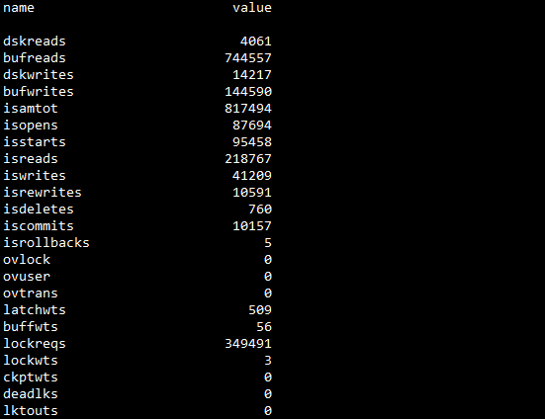
说明 | dskreads Number of actual reads from disk  bufreads Number of reads from shared memory  dskwrites Actual number of writes to disk  bufwrites Number of writes to shared memory  isamtot Total number of calls  isopens isopen calls  isstarts isstart calls  isreads isread calls  iswrites iswrite calls  isrewrites isrewrite calls  isdeletes isdelete calls  iscommits iscommit calls  isrollbacks isrollback calls  ovlock Overflow lock table  ovuser Overflow user table  ovtrans Overflow transaction table  latchwts Latch request waits  bufwts Buffer waits  lockreqs Lock requests  lockwts Lock waits  ckptwts Checkpoint waits  deadlks Deadlocks  lktouts Deadlock time-outs  numckpts Number checkpoints  plgpagewrites Physical-log pages written  plgwrites Physical-log writes  llgrecs Logical-log records  llgpagewrites Logical-log writes  llgwrites Logical-log pages written  pagreads Page reads  pagwrites Page writes  flushes Buffer-pool flushes  compress Page compresses  fgwrites Foreground writes  lruwrites Least-recently used (LRU) writes  chunkwrites Writes during a checkpoint  btradata Read-ahead data pages read through index leaf node  btraidx Read-ahead data pages read through index branch or root node  dpra Data pages read into memory with read-ahead feature  rapgs_used Read-ahead data pages that user used  seqscans Sequential scans  totalsorts Total sorts  memsorts Sorts that fit in memory  disksorts Sorts that did not fit in memory  maxsortspace Maximum disk space used by a sort
    - Checkpoint
查看数据库实例Check Point的历史情况
dbaccess sysmaster
select * from syscheckpoint;
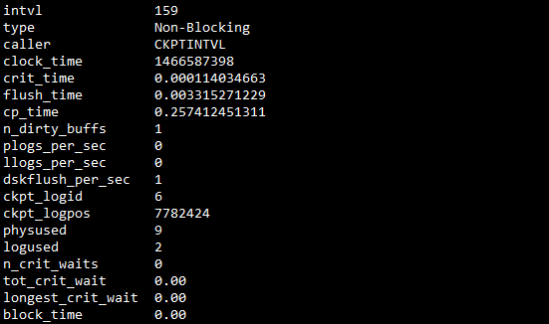
说明 | onstat -g ckp
  - CPU
    - CPU VP Profile
查看数据库实例CPU VP的状态
dbaccess sysmaster
select * from sysvpprof;
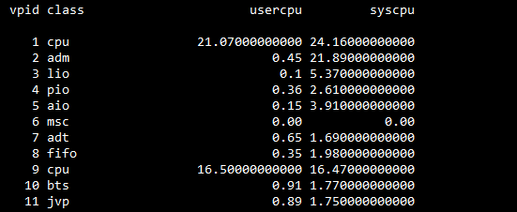
说明 | 只包含有sys_cpu和user_cpu

    - CPU VP List
查看数据库实例CPU VP的状态
dbaccess sysmaster
select vpid,classname class,pid,round(usecs_user,2) user_cpu,round(usecs_sys,2) sys_cpu,num_ready,
total_semops,total_busy_wts,total_yields,total_spins,vp_cache_size,vp_cache_allocs
from sysvplst ;
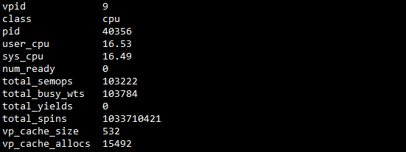
说明

  - Memory
    - Buffer Pool
查看数据库实例LRU的状态
dbaccess sysmaster
select indx,bufsize pagesize,nbuffs buffers,format_units(nbuffs*bufsize,'B') buffsize,nlrus,mindirty,maxdirty,
(bufwaits / (bufwrites + pagreads)) * 100.00 buff_wait_rate,
100 * (bufreads-dskreads)/ bufreads buff_read_rate,
100 * (bufwrites-dskwrites)/ bufwrites buff_write_rate,fgwrites,lruwrites ,chunkwrites
from sysbufpool;
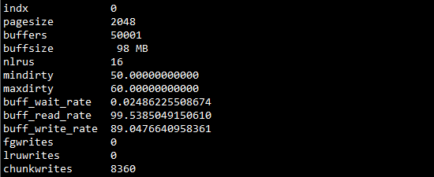
说明 | onstat -p  onstat -g seg  onstat -R  onstat -F
    - LRU
查看数据库实例LRU的状态
dbaccess sysmaster
select
bpoolindx,
lru_num,lru_nfree,lru_nmod,
lru_nfree/(lru_nfree+lru_nmod) free_rate,lru_nmod/(lru_nfree+lru_nmod) mod_rate
from syslrus;
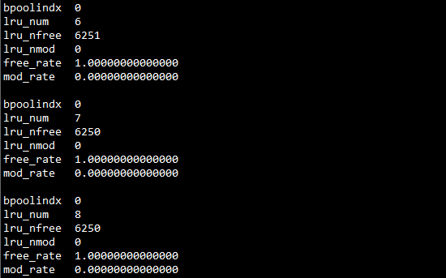
说明

  - Disk
    - DBSpaces
查看数据库实例的DBSpaces空间的类型、状态及空间使用情况
dbaccess sysmaster
SELECT A.dbsnum as No, trim(B.name) as name,
CASE WHEN (bitval(B.flags,'0x10')>0 AND bitval(B.flags,'0x2')>0)
THEN 'MirroredBlobspace'
WHEN bitval(B.flags,'0x10')>0 THEN 'Blobspace'
WHEN bitval(B.flags,'0x2000')>0 AND bitval(B.flags,'0x8000')>0
THEN 'TempSbspace'
WHEN bitval(B.flags,'0x2000')>0 THEN 'TempDbspace'
WHEN (bitval(B.flags,'0x8000')>0 AND bitval(B.flags,'0x2')>0)
THEN 'MirroredSbspace'
WHEN bitval(B.flags,'0x8000')>0 THEN 'SmartBlobspace'
WHEN bitval(B.flags,'0x2')>0 THEN 'MirroredDbspace'
ELSE 'Dbspace'
END as dbstype,
CASE WHEN bitval(B.flags,'0x4')>0 THEN 'Disabled'
WHEN bitand(B.flags,3584)>0 THEN 'Recovering'
ELSE 'Operational'
END as dbsstatus,
format_units(sum(chksize), 'p') as DBS_SIZE ,
format_units(sum(decode(mdsize,-1,nfree,udfree)), 'p') as free_size,
TRUNC(100-sum(decode(mdsize,-1,nfree,udfree))*100/sum(chksize),2)||'%' as used,
TRUNC(MAX(A.pagesize/1024)) as pgsize,
MAX(B.nchunks) as nchunks
FROM syschktab A, sysdbstab B
WHERE A.dbsnum = B.dbsnum
GROUP BY A.dbsnum,name, 3, 4
ORDER BY A.dbsnum;
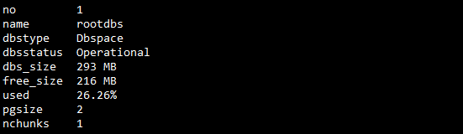
说明 | Dbspace的chunk数量、类型、状态（Operational为正常状态）,空间的大小、已用空间及已用空间的百分比.
    - Chunks
查看数据库实例的chunks空间的状态及空间使用情况
dbaccess sysmaster
SELECT A.chknum as num, B.name as spacename,
trunc(A.pagesize/1024)||' KB' as pgsize,
format_units(A.offset, A.pagesize) as off,
format_units(A.chksize, A.pagesize) as size,
format_units(decode(A.mdsize,-1,A.nfree,A.udfree),A.pagesize) as free,
TRUNC(100 - decode(A.mdsize,-1,A.nfree,A.udfree)*100/A.chksize,2 )|| '%' as used,
A.fname
FROM syschktab A, sysdbstab B
WHERE A.dbsnum = B.dbsnum
order by B.dbsnum;
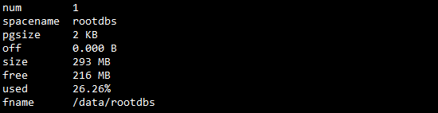
说明

    - Chunks I/O
查看chunk IO 分布情况
dbaccess sysmaster
select d.name dbspace, fname[1,125] chunk_name,
reads read_count,
writes write_count,
reads+writes total_count,
pagesread,
pageswritten,
pagesread+pageswritten total_pg
from sysmaster:syschkio c, sysmaster:syschunks k, sysmaster:sysdbspaces d
where d.dbsnum = k.dbsnum
and k.chknum = c.chunknum --# c.chknum
order by 8 desc;
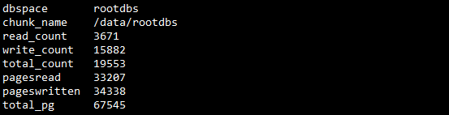
说明

    - Logical Log
查看数据库实例逻辑日志
dbaccess sysmaster
SELECT A.number as num, A.uniqid as uid, format_units(A.size,'P') as size,
TRIM( TRUNC(A.used*100/A.size,0)||'%') as used,
d.name as spacename,
TRIM( A.chunk||'_'||A.offset ) as location,
decode(A.filltime,0,'NotFull',
dbinfo('UTC_TO_DATETIME', A.filltime)::varchar(50)) as filltime,
CASE WHEN bitval(A.flags,'0x1') > 0 AND bitval(A.flags,'0x4')>0
THEN 'UsedBackedUp'
WHEN bitval(A.flags,'0x1') > 0 AND bitval(A.flags,'0x2')>0
THEN 'UsedCurrent'
WHEN bitval(A.flags,'0x1') > 0 THEN 'Used'
ELSE hex(A.flags)::varchar(50)
END as flags,
CASE WHEN A.filltime-B.filltime > 0 THEN
format_units(CAST(TRUNC(A.size/(A.filltime-B.filltime),4)
as varchar(20)) ,'P')||'/S'
ELSE ' N/A ' END as pps
FROM syslogfil A, syslogfil B,syschktab c, sysdbstab d
WHERE A.uniqid-1 = B.uniqid
and c.dbsnum = d.dbsnum
and a.chunk=c.chknum
UNION
SELECT A.number as num, A.uniqid as uid, format_units(A.size,'P') as size,
TRIM( TRUNC(A.used*100/A.size,0)||'%') as used,
d.name as spacename,
TRIM( A.chunk||'_'||A.offset ) as location,
decode(A.filltime,0,'NotFull',
dbinfo('UTC_TO_DATETIME', A.filltime)::varchar(50)) as filltime,
CASE WHEN bitval(A.flags,'0x1') > 0 AND bitval(A.flags,'0x4')>0
THEN 'UsedBackedUp'
WHEN bitval(A.flags,'0x1') > 0 AND bitval(A.flags,'0x2')>0
THEN 'UsedCurrent'
WHEN bitval(A.flags,'0x1') > 0 THEN 'Used'
WHEN bitval(A.flags,'0x8') > 0 THEN 'NewAdd'
ELSE hex(A.flags)::varchar(50) END as flags,
'N/A' as pps
FROM syslogfil A ,syschktab c, sysdbstab d
WHERE ( A.uniqid = (SELECT min(uniqid) FROM syslogfil WHERE uniqid > 0)
OR A.uniqid = 0 )
and c.dbsnum = d.dbsnum
and a.chunk=c.chknum
ORDER BY A.uniqid ;
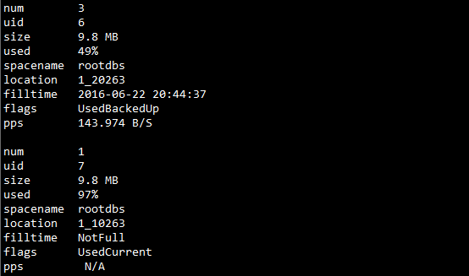
说明 | 类似onsat -l
    - Logical logfile backup times (onbar)
查看数据库逻辑日志备份时间
dbaccess sysutils
SELECT a.obj_name::VARCHAR(10) AS logfile,
b.act_start, b.act_end,
(b.act_end - b.act_start)::INTERVAL SECOND(9) TO SECOND AS time_sec
FROM bar_object a, bar_action b
WHERE a.obj_oid = b.act_oid
AND a.obj_type = 'L'
ORDER BY 1 ASC;
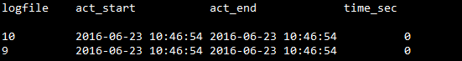
说明

    - Physical Log
查看数据库实例物理日志
dbaccess sysmaster
SELECT
B.name as spacename, A.fname ,
pl_chunk||'_'||pl_offset as location,
format_units(pl_physize,'P') as size,
format_units(pl_phyused,'P') as used,
format_units(pl_bufsize,'P') as bufsize,
format_units(pl_phypos,'P') as start
FROM sysplog p, syschktab A, sysdbstab B
WHERE A.dbsnum = B.dbsnum
and p.pl_chunk=a.chknum;
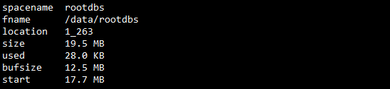
说明 | Fname为physical log所在dbspace的chunck信息，location: 1表示对应chunck的编号，263为page信息
  - Network
    - Network SQLHosts
查看数据库实例的SQLHOSTS值
dbaccess sysmaster
select dbsvrnm,nettype,hostname,svcname,options,
svrsecurity,netbuf_size,svrgroup
from syssqlhosts;
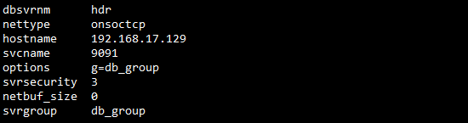
说明 | 快速查看实例的网络配置
    - Network Status
查看网络连接情况信息
dbaccess sysmaster
select nc_name::char(8) name, nc_accepted,nc_rejected,nc_reads,nc_writes
from sysnetclienttype
where nc_reads>0;
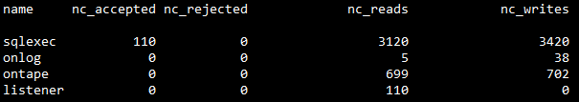
说明

  - Session
    - Sessions Connection Time
查看Session的连接时间信息
dbaccess sysmaster
select s.sid,s.pid, s.username, s.hostname,q.odb_dbname database,
dbinfo('UTC_TO_DATETIME',s.connected) connection_time,
current - dbinfo('UTC_TO_DATETIME',s.connected)
connected_since
from syssessions s, sysopendb q
where s.sid = q.odb_sessionid;
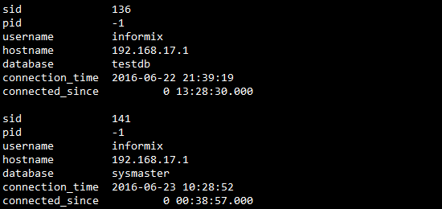
说明 | Pid 为-1的情况，有些是从长连接。
    - Sessions Idle Time
查看Session的空闲时间信息
dbaccess sysmaster
SELECT s.sid, s.username, s.hostname, q.odb_dbname database,
dbinfo('UTC_TO_DATETIME',s.connected) conection_time,
dbinfo('UTC_TO_DATETIME',t.last_run_time) last_run_time,
current - dbinfo('UTC_TO_DATETIME',t.last_run_time) idle_time
FROM syssessions s, systcblst t, sysrstcb r, sysopendb q
WHERE t.tid = r.tid AND s.sid = r.sid AND s.sid = q.odb_sessionid
ORDER BY 7 DESC;
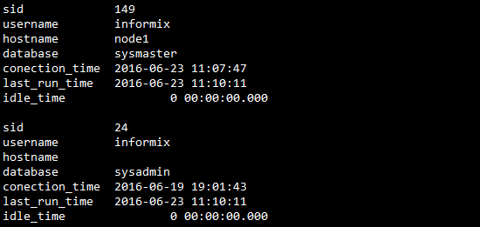
说明 | 说明 若发现有大量的idle_time非常大的session，表示有大量的连接长时间处于空闲状态，一般出现在采用长连接的情况，而配置了过多的长连接，但实际使用的较少。
    - Sessions Waiting on Resources
查看等待资源的Sessions
dbaccess sysmaster
select sid,pid, username, hostname
is_wlatch, -- blocked waiting on a latch
is_wlock, -- blocked waiting on a locked record or table
is_wbuff, -- blocked waiting on a buffer
is_wckpt, -- blocked waiting on a checkpoint
is_incrit -- session is in a critical section of transaction-- (e.g writting to disk)
from syssessions
order by username;
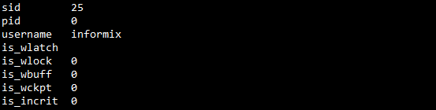
说明 | 可以按不同的列排序，找到等待某资源最多的session，并加以判断和解决问题。
    - Sessions I/O
查看Sessions的I/O情况
dbaccess sysmaster
select syssesprof.sid,
isreads,
iswrites,
isrewrites,
isdeletes,
bufreads,
bufwrites,
seqscans ,
pagreads ,
pagwrites,
total_sorts ,
dsksorts ,
max_sortdiskspace,
logspused
from syssesprof, syssessions
where syssesprof.sid = syssessions.sid;
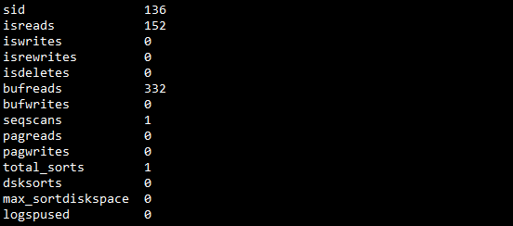
说明 | 可以通过对不同的属性进行排序找到TOP N的Sessions。
    - Sessions Lock
查看Sessions的锁情况
dbaccess sysmaster
select syssesprof.sid,
lockreqs ,
locksheld ,
lockwts ,
deadlks ,
lktouts
from syssesprof, syssessions
where syssesprof.sid = syssessions.sid
--And syssesprof.sid=540
;
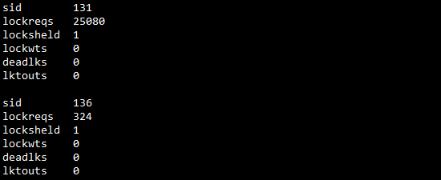
说明 | 找出有锁问题的session
  - SQL
    - Current Executing SQL
查看正在运行的SQL语句
dbaccess sysmaster
select
username,
sqx_sessionid,
sqx_sqlstatement
from sysmaster:syssqexplain, sysmaster:sysscblst
where sqx_sessionid = sid
--and sqx_sqlstatement like '%tabname%';
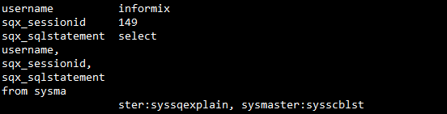
说明 | 1. 找到当前所有执行的SQL语句  2. 找到特定表是否有SQL正在访问。当某一个表正被不加锁的方式访问时，不可以对表进行DDL操作，此时可以通过此方法找到相应SQL，通过onmode -z sid 结束。
    - Current Slowest SQL
查看当前运行慢的SQL，消耗资源多的SQL
dbaccess sysmaster
select first 25 sqx_estcost,
sqx_estrows, sqx_sessionid,
sqx_sqlstatement
from sysmaster:syssqexplain
where 1=1
order by sqx_estcost desc;
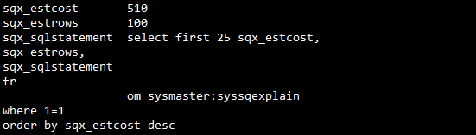
说明 | 说明 更多的属性,如通过sqx_seqscan找出顺序扫描的SQL。通过sqx_dsksorts找到有磁盘排序的SQL。  sqx_bufreads,sqx_pagereads,sqx_bufwrites,  sqx_pagewrites,sqx_totsorts,sqx_dsksorts,  sqx_sortspmax,sqx_conbno,sqx_ismain,sqx_selflag,  sqx_estcost,sqx_estrows,sqx_seqscan,sqx_srtscan,  sqx_autoindex,sqx_index,sqx_remsql,sqx_mrgjoin,  sqx_dynhashjoin,sqx_keyonly,sqx_tempfile,
    - History Slowest SQL
查看历史运行慢的SQL，消耗资源多的SQL
dbaccess sysmaster
select * from sysmaster:syssqltrace;
--Sequence Scan SQL
select distinct sql_statement
from sysmaster:Syssqltrace t
inner join sysmaster:syssqltrace_iter i
on t.sql_id = i.sql_id
where i.sql_itr_info='Seq Scan'
;

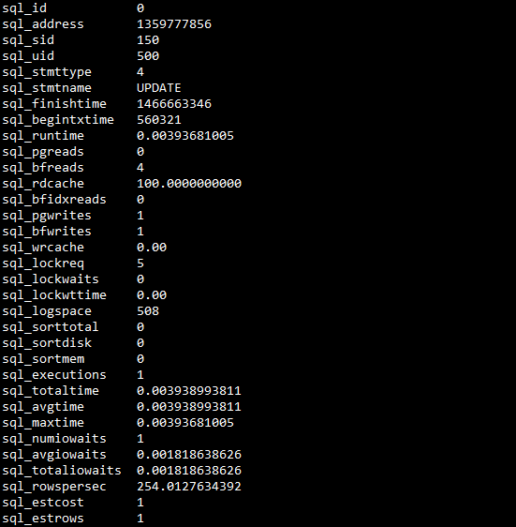
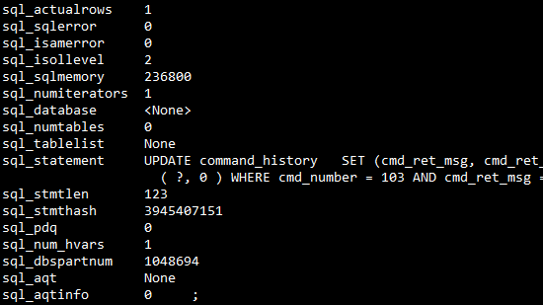
说明 | 打开SQLTRACE跟踪SQL，  echo 'execute function task ("set sql tracing on",100000, "1k", "low","demodb");' | dbaccess sysadmin  关闭SQLTRACE功能  echo ' execute function sysadmin:task("SET SQL TRACING OFF"); ' | dbaccess sysadmin  查询速度SQL  echo "select * from sysmaster:syssqltrace where sql_id=3"| dbaccess demodb
  - Lock
    - Locks on Table
查看表上的锁的个数
dbaccess sysmaster
select tabname,
sum(pf_rqlock) as locks,
sum(pf_wtlock) as lockwaits,
sum(pf_deadlk) as deadlocks
from sysactptnhdr,systabnames
where
systabnames.partnum = sysactptnhdr.partnum
and dbsname = "demodb"
--and pf_wtlock >=0
--and pf_rqlock >=0
group by tabname
order by lockwaits desc;
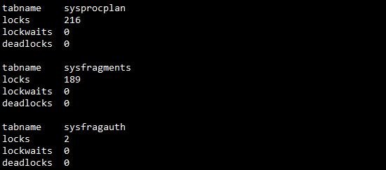
说明 | 查看表上的lock的数量，是否有lock wait和dead lock问题  onstat -g ppf
    - Lock List and Lock waiter
查看当前锁及锁等待者
dbaccess sysmaster
select
dbsname,b.tabname,rowidr,keynum,
e.txt type,d.sid owner,g.username ownername,f.sid waiter,
h.username waitname
from syslcktab a,systabnames b,systxptab c,sysrstcb d,
sysscblst g,flags_text e, outer ( sysrstcb f , sysscblst h )
where a.partnum = b.partnum
and a.owner = c.address
and c.owner = d.address
and a.wtlist = f.address
and d.sid = g.sid
and e.tabname = 'syslcktab'
and e.flags = a.type
and f.sid = h.sid
and dbsname='demodb'
and b.tabname ='t';
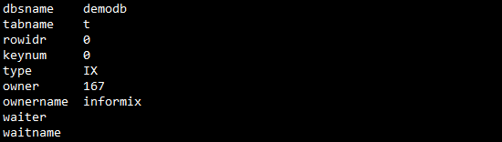
说明 | onstat -k，修改demodb为库名，修改t为表名
  - Transaction
    - Transactions Info
当前事务的基本信息
dbaccess sysmaster
select
t.username,
t.sid,
tx_logbeg,
tx_loguniq,
tx_logpos,
tx_nlocks,
tx_isolevel,
tx_longtx
from systrans x, sysrstcb t
where tx_owner = t.address
--and t.sid=599
;
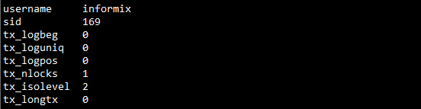
说明

    - Transactions and Logs
事务与逻辑日志相关信息
dbaccess sysmaster
-- select transaction data into a temp table
select tx_logbeg, tx_loguniq
from systrans
into temp b;
-- count how may transactions begin in each log
select tx_logbeg, count(*) cnt
from B
where tx_logbeg > 0
group by tx_logbeg
into temp C;
-- count how many transactions currently are in each log
select tx_loguniq, count(*) cnt
from B
where tx_loguniq > 0
group by tx_loguniq
into temp D;
-- join data from counts with syslogs
select
uniqid,size,
is_backed_up, -- 0 = no, 1 = yes log is backed up
is_archived, -- 0 = no, 1 = yes log is on last archive
c.cnt tx_beg_cnt,
d.cnt tx_curr_cnt
from syslogs, outer c, outer D
where uniqid = c.tx_logbeg
and uniqid = d.tx_loguniq order by uniqid;
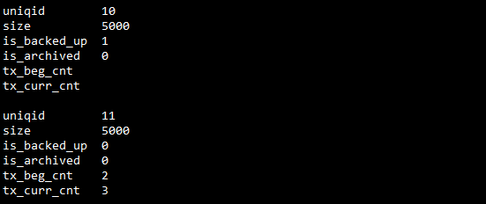
说明

- Database
    - Database Basic Info
查实例下的每一个数据库的：创建者、创建日期、默认的dbspace以及当前使用的日志模式
dbaccess sysmaster
SELECT trim(name) dbname,trim(owner) owner,created,
TRIM(DBINFO('dbspace',partnum)) AS dbspace,
CASE WHEN is_logging+is_buff_log=1 THEN "Unbuffered logging"
WHEN is_logging+is_buff_log=2 THEN "Buffered logging"
WHEN is_logging+is_buff_log=0 THEN "No logging"
ELSE "" END Logging_mode
FROM sysdatabases;
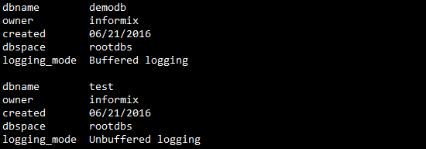
说明 | 数据库日志模式有：No logging,Buffered logging,Unbuffered logging三种
    - Database Space Usage
查实例下的每一个数据库已分配占用的空间及已经使用的空间
dbaccess sysmaster
select t1.dbsname,
format_units(sum(ti_nptotal),max(ti_pagesize)) allocated_size,
format_units(sum(ti_npused),max(ti_pagesize)) used_size
from systabnames t1, systabinfo t2,sysdatabases t3
where t1.partnum = t2.ti_partnum
and trim(t3.name)=trim(t1.dbsname)
group by dbsname
order by sum(ti_nptotal) desc;
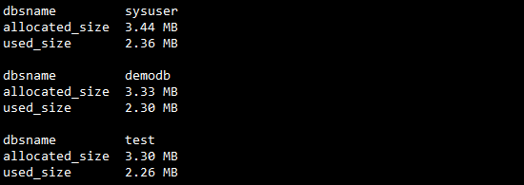
说明 | 统计每一个数据库使用空间的具体情况。根据数据库的每一个表所使用空间的情况进行统计
- Database Objects
  - Table
    - Table Created time
表创建的详细时间点
dbaccess sysmaster
select
st.owner,
st.dbsname,
t.tabname,
dbinfo('UTC_TO_DATETIME',ti.ti_created) tab_createtime,
t.locklevel
from demodb:systables t, sysmaster:systabinfo ti,sysmaster:systabnames st
where t.tabid>99
and st.partnum = ti.ti_partnum
and t.tabname = st.tabname
-- and t.tabid=102
-- and t.tabname='tabname'
--and dbinfo('UTC_TO_DATETIME',ti.ti_created)>='2010-11-03 08:00:00'
and st.dbsname='demodb'
order by t.tabname;
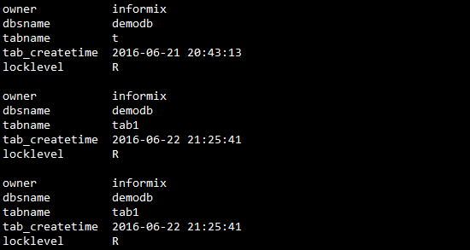
说明

    - Tables Space
表空间使用情况统计
dbaccess sysmaster
--A 含分片
select
st.dbsname databasename,st.tabname,sd.name dbs_name,
ti_nextns extents,
sin.ti_nrows,sin.ti_pagesize, sin.ti_rowsize,
sin.ti_nptotal nptotal, format_units(sin.ti_nptotal,sd.pagesize) total_size,
sin.ti_npused npused, format_units(sin.ti_npused,sd.pagesize) used_size,
sin.ti_nextsiz nextsize
from sysmaster:systabnames st, sysmaster:sysdbspaces sd,sysmaster:systabinfo sin,demodb:systables dt
where sd.dbsnum = trunc(st.partnum/1048576)
and dt.tabid>99
and dt.tabname=st.tabname
and st.partnum=sin.ti_partnum
and st.dbsname='demodb'
--and sd.name='demodbs'
order by 10 desc;
--B 总和
select
st.dbsname databasename,st.tabname,
sum(ti_nextns) extents,
sum(sin.ti_nrows) nrows,max(sin.ti_pagesize) pagesize,
sum(sin.ti_nptotal) nptotal, format_units(sum(sin.ti_nptotal),max(sd.pagesize)) total_size,
sum(sin.ti_npused) npused, format_units(sum(sin.ti_npused),max(sd.pagesize)) used_size
from sysmaster:systabnames st, sysmaster:sysdbspaces sd,sysmaster:systabinfo sin,demodb:systables dt
where sd.dbsnum = trunc(st.partnum/1048576)
and dt.tabid>99
and dt.tabname=st.tabname
and st.partnum=sin.ti_partnum
and st.dbsname='demodb'
group by 1,2
order by 8 desc;
A 含分片
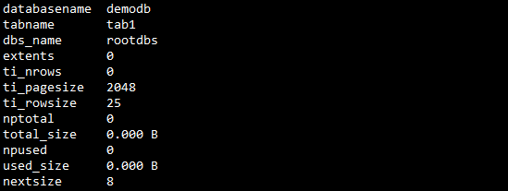
B 总和
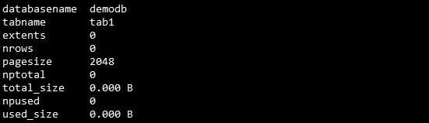
说明

    - Tables IO
表IO情况，表IO的行为统计
dbaccess sysmaster
SELECT p.tabname,
sum(sin.ti_nrows) nrows,
format_units(sum(sin.ti_nptotal),max(sd.pagesize)) total_size,
format_units(sum(sin.ti_npused),max(sd.pagesize)) used_size,
sum(seqscans) as seqscans ,
sum( pagreads) diskreads,
sum(bufreads) bufreads,
sum( bufwrites) bufwrites,
sum( pagwrites) diskwrites,
sum( pagreads)+ sum( pagwrites) disk_rsws ,
trunc ( decode ( sum(bufreads) , 0 , 0 , ( 100 - (( sum(pagreads) * 100 ) / sum(bufreads+pagreads))) ) , 2 ) as rbufhits ,
trunc ( decode ( sum(bufwrites) , 0 , 0 , ( 100 - (( sum(pagwrites) * 100 ) / sum(bufwrites+pagwrites))) ) , 2 ) as wbufhits
from demodb:systables s , sysmaster:sysptprof p ,
sysmaster:systabinfo sin, sysmaster:sysdbspaces sd,sysmaster:systabnames st
where s.tabid>99
and s.tabname = p.tabname
and p.dbsname=st.dbsname
and sd.dbsnum = trunc(st.partnum/1048576)
and p.partnum=st.partnum
and s.tabname=st.tabname
and st.partnum=sin.ti_partnum
and st.dbsname='demodb'
group by 1
order by 10 desc;
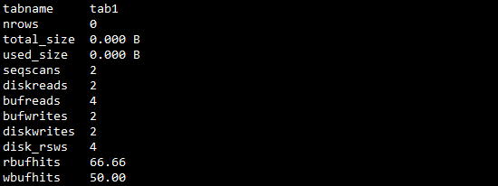
说明 | 可以根据不同的指标进行排序，如按seqscans，可以得到顺序扫描的表的情况
    - Tables In Rootdbs
创建在rootdbs上的表
dbaccess sysmaster
SELECT UNIQUE e.dbsname dbname, e.tabname
FROM sysdbspaces d, syschunks c, sysextents e
WHERE d.name = 'rootdbs'
AND c.dbsnum = d.dbsnum
AND e.chunk = c.chknum
AND e.dbsname NOT IN ('rootdbs', 'sysmaster', 'sysadmin', 'sysuser', 'sysutils')
ORDER BY 1, 2;
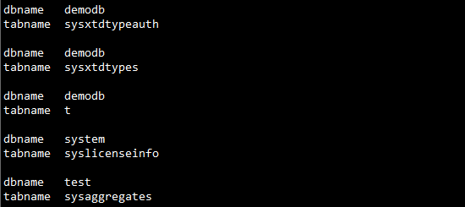
说明

    - Tables Update Statistics
表统计更新情况
dbaccess demodb
select systables.tabname,
syscolumns.colname,
sysdistrib.constructed,mode
from sysdistrib,systables,syscolumns
where systables.tabid > 99
and systables.tabid = syscolumns.tabid
and sysdistrib.tabid=systables.tabid
and sysdistrib.colno = syscolumns.colno
group by 1,2,3,4
order by tabname,colname;
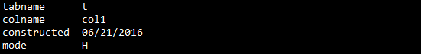
说明

    - Temp Table
临时表信息，包括 ：显式、隐式创建的临时表，排序用的临时表，group用的临时表，表关联Join用的临时表情况
dbaccess sysmaster
select
trim(n.dbsname) tab_type,
trim(n.owner) users,
trim(n.tabname) tab_name,
dbinfo('UTC_TO_DATETIME',i.ti_created) index_createtime,
trim(dbinfo('DBSPACE', i.ti_partnum)) dbspace,
format_units(i.ti_nptotal,i.ti_pagesize) total_size,
i.ti_nrows
FROM sysmaster:systabnames n, sysmaster:systabinfo i
WHERE (sysmaster:bitval(i.ti_flags, 32) = 1
OR sysmaster:bitval(i.ti_flags, 64) = 1
OR sysmaster:bitval(i.ti_flags, 128) = 1)
AND i.ti_partnum = n.partnum
order by 1,3
;
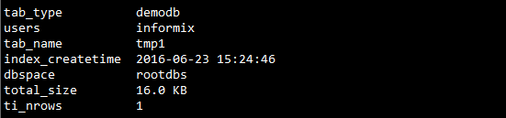
说明 | 1．SortTEMP是用来排序用的临时空间，合理调整参数: DS_NONPDQ_QUERY_MEM，减少磁盘排序；  2．确定是否有临时表存储的dbspace不是临时表空间的情况，那可能由于没有正确配置好临时表空间，或者没有在创建临时表时使用with no log选项。  3．找出没有创建在临时表空间上的Temp table。  select t.dbsname, t.tabname, hex(p.partnum) partition, hex(p.flags) pflags  from sysmaster:systabnames t, sysmaster:sysptnhdr p  where t.partnum = p.partnum  and hex(mod(p.flags,256)/16) IN ( 6,2 ) -- Looking for temp tables  and trunc(p.partnum / 1048576) -- Filter: Only temps not in  in (select dbsnum -- temp dbspace  from sysdbspaces where is_temp = 0)  order by dbsname, tabname, partition;
    - Table Statistics
查询表统计信息更新情况
dbaccess sysmaster
select
trim(n.dbsname) tab_type,
trim(n.owner) users,
trim(n.tabname) tab_name,
dbinfo('UTC_TO_DATETIME',i.ti_created) index_createtime,
trim(dbinfo('DBSPACE', i.ti_partnum)) dbspace,
format_units(i.ti_nptotal,i.ti_pagesize) total_size,
i.ti_nrows
FROM sysmaster:systabnames n, sysmaster:systabinfo i
WHERE (sysmaster:bitval(i.ti_flags, 32) = 1
OR sysmaster:bitval(i.ti_flags, 64) = 1
OR sysmaster:bitval(i.ti_flags, 128) = 1)
AND i.ti_partnum = n.partnum
order by 1,3
;
说明 | 1．SortTEMP是用来排序用的临时空间，合理调整参数: DS_NONPDQ_QUERY_MEM，减少磁盘排序；  2．确定是否有临时表存储的dbspace不是临时表空间的情况，那可能由于没有正确配置好临时表空间，或者没有在创建临时表时使用with no log选项。  3．找出没有创建在临时表空间上的Temp table。  select t.dbsname, t.tabname, hex(p.partnum) partition, hex(p.flags) pflags  from sysmaster:systabnames t, sysmaster:sysptnhdr p  where t.partnum = p.partnum  and hex(mod(p.flags,256)/16) IN ( 6,2 ) -- Looking for temp tables  and trunc(p.partnum / 1048576) -- Filter: Only temps not in  in (select dbsnum -- temp dbspace  from sysdbspaces where is_temp = 0)  order by dbsname, tabname, partition;
  - Index
    - Index Created Time
查看索引的创建时间信息
dbaccess sysmaster
select unique
i.owner,
st.dbsname,
t.tabname,
i.idxname,
dbinfo('UTC_TO_DATETIME',ti.ti_created) index_createtime
from demodb:systables t, demodb:sysindexes i ,sysmaster:systabinfo ti,sysmaster:systabnames st
where t.tabid=i.tabid
and t.tabid>99
and st.partnum = ti.ti_partnum
and i.idxname = st.tabname
-- and t.tabid=102
-- and t.tabname='tabname'
--and dbinfo('UTC_TO_DATETIME',ti.ti_created)>='2010-11-03 08:00:00'
and st.dbsname='demodb'
order by t.tabname;
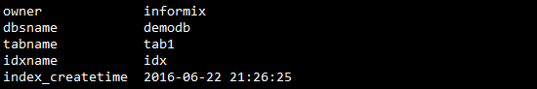
说明 | 修改数据库demodb。  对于分片表，对应的attached索引会有多个，每个索引的创建时间会有所差异
    - Index Script
导出Index的脚本及相关信息
dbaccess sysmaster
Select distinct
--st.dbsname,
--t.tabname,
--i.idxname,
--dbinfo('UTC_TO_DATETIME',ti.ti_created) index_createtime,
trim(trim(case when i.part1>0 then (select 'CREATE '||case when i.idxtype='U' then ' UNIQUE ' else '' end||case when i.clustered='C' then ' CLUSTER ' else '' end||' INDEX '||i.idxname||' ON ' ||t.tabname||' ('||colname from demodb:syscolumns where colno=i.part1 and tabid=i.tabid) else '' end)||
trim(case when i.part2>0 then (select ','||colname from demodb:syscolumns where colno=i.part2 and tabid=i.tabid) else '' end)||
trim(case when i.part3>0 then (select ','||colname from demodb:syscolumns where colno=i.part3 and tabid=i.tabid) else '' end)||
trim(case when i.part4>0 then (select ','||colname from demodb:syscolumns where colno=i.part4 and tabid=i.tabid) else '' end)||
trim(case when i.part5>0 then (select ','||colname from demodb:syscolumns where colno=i.part5 and tabid=i.tabid) else '' end)||
trim(case when i.part6>0 then (select ','||colname from demodb:syscolumns where colno=i.part6 and tabid=i.tabid) else '' end)||
trim(case when i.part7>0 then (select ','||colname from demodb:syscolumns where colno=i.part7 and tabid=i.tabid) else '' end)||
trim(case when i.part8>0 then (select ','||colname from demodb:syscolumns where colno=i.part8 and tabid=i.tabid) else '' end)||
trim(case when i.part9>0 then (select ','||colname from demodb:syscolumns where colno=i.part9 and tabid=i.tabid) else '' end)||
trim(case when i.part10>0 then (select ','||colname from demodb:syscolumns where colno=i.part10 and tabid=i.tabid) else '' end)||
trim(case when i.part11>0 then (select ','||colname from demodb:syscolumns where colno=i.part11 and tabid=i.tabid) else '' end)||
trim(case when i.part12>0 then (select ','||colname from demodb:syscolumns where colno=i.part12 and tabid=i.tabid) else '' end)||
trim(case when i.part13>0 then (select ','||colname from demodb:syscolumns where colno=i.part13 and tabid=i.tabid) else '' end)||
trim(case when i.part14>0 then (select ','||colname from demodb:syscolumns where colno=i.part14 and tabid=i.tabid) else '' end)||
trim(case when i.part15>0 then (select ','||colname from demodb:syscolumns where colno=i.part15 and tabid=i.tabid) else '' end)||
trim(case when i.part16>0 then (select ','||colname from demodb:syscolumns where colno=i.part16 and tabid=i.tabid) else '' end ))||');' index_script
from demodb:systables t, demodb:sysindexes i ,sysmaster:systabinfo ti,sysmaster:systabnames st
where t.tabid=i.tabid
and t.tabid>99
and st.partnum = ti.ti_partnum
and i.idxname = st.tabname
-- and t.tabid=102
-- and t.tabname='tabname'
--and dbinfo('UTC_TO_DATETIME',ti.ti_created)>='2010-11-03 08:00:00'
and st.dbsname='demodb'
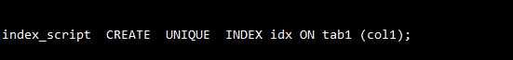
说明 | 修改数据库demodb
    - Index Space
索引空间使用情况统计
dbaccess sysmaster
--A 含分片
select
st.dbsname databasename,dt.tabname,di.idxname,sd.name dbs_name,
di.levels,sin.ti_nextns extents,
sin.ti_nptotal nptotal, format_units(sin.ti_nptotal,sd.pagesize) total_size,
sin.ti_npused npused, format_units(sin.ti_npused,sd.pagesize) used_size
from sysmaster:systabnames st, sysmaster:sysdbspaces sd,sysmaster:systabinfo sin,
demodb:sysindexes di,demodb:systables dt
where sd.dbsnum = trunc(st.partnum/1048576)
and dt.tabid>99
and di.idxname = st.tabname
and dt.tabid=di.tabid
and st.partnum=sin.ti_partnum
and st.dbsname='demodb'
--and sd.name='demodbs'
order by 2,1,3;
--B 总和
select
st.dbsname databasename,dt.tabname,di.idxname ,
max(di.levels) levels,max(sin.ti_nextns) extents,
sum(sin.ti_nptotal) nptotal, format_units(sum(sin.ti_nptotal),max(sd.pagesize)) total_size,
sum(sin.ti_npused) npused, format_units(sum(sin.ti_npused),max(sd.pagesize)) used_size
from sysmaster:systabnames st, sysmaster:sysdbspaces sd,sysmaster:systabinfo sin,
demodb:sysindexes di,demodb:systables dt
where sd.dbsnum = trunc(st.partnum/1048576)
and dt.tabid>99
and di.idxname = st.tabname
and dt.tabid=di.tabid
and st.partnum=sin.ti_partnum
and st.dbsname='demodb'
group by 1,2,3
order by 8 desc;
A 含分片
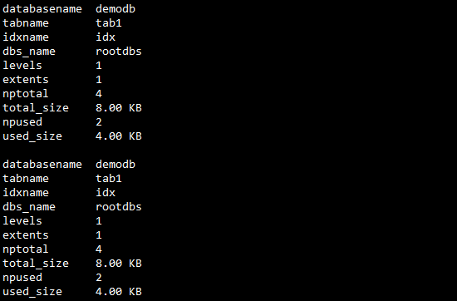
B 总和
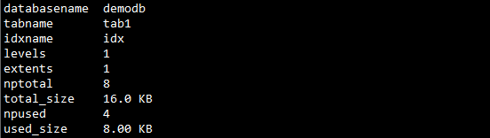
说明 | 修改数据库demodb。  修改条件--and sd.name='demodbs' 查询指定dbspace下的所有index情况  对于分片索引，则有多条记录来展示在每一个分片上的信息

  - Procedure
    - Procedure Script
导出UDR脚本
dbaccess demodb
select data
from sysprocbody t1,sysprocedures t2
where t1.datakey='T'
and t1.procid=t2.procid
--and t1.procid=541
and t2.mode='O'
order by t1.procid,t1.seqno;
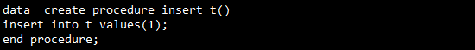
说明 | SPL的脚本，输出结果类似于:dbschema -d demodb -f all

